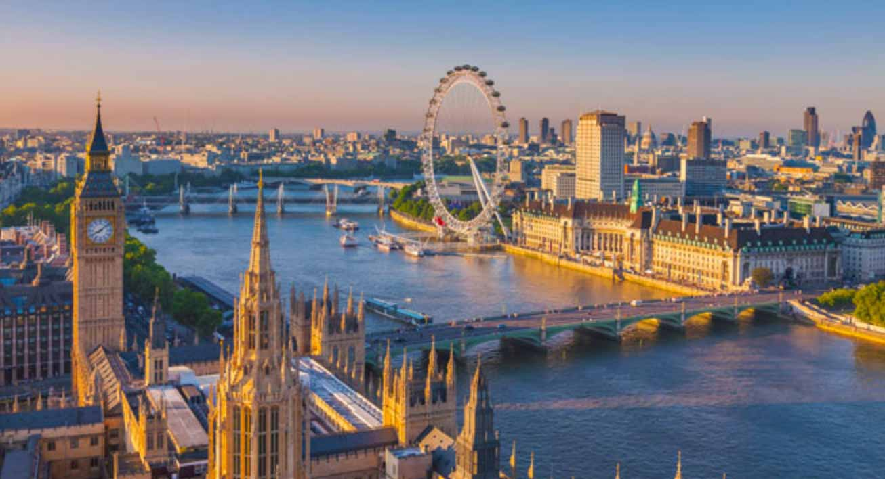
http://www.novini.london/%D0%BD%D0%BE%D0%B2%D0%B8%D0%BD%D0%B0/7974-%D0%9B%D0%BE%D0%BD%D0%B4%D0%BE%D0%BD-%D1%80%D0%B0%D0%B9-%D0%B7%D0%B0-%D0%B1%D0%BE%D0%B3%D0%B0%D1%82%D0%B0%D1%88%D0%B8%D1%82%D0%B5
Top 5 places of interest in London
London is a capital of the Great Britain and one of the most populous and the most interesting cities in the world. It lies on the river Thames and stretches for about 30 miles from east to west. London has an ancient history, it was founded by the Romans more than 2 thousand years ago and nowadays is considered to be a metropolis. Also, London from old periods was an official residence of kings and queens. Nowadays British Royal Family lives here in the Buckingham Palace.
London is one of the leading global cities, it is an art, business, educational, scientific, fashion, media, transport, tourist, and entertaining center of Great Britain. London is one of the most popular cultural capitals being especially rich in historic palaces and churches. It was recognized as the world’s most-visited city by international arrivals. It attracts more and more tourists every year who come to see such famous sights here as the Houses of Parliament, the Buckingham Palace, the Westminster Abbey, the Tower Bridge, Big Ben and others.
- The Houses of Parliament
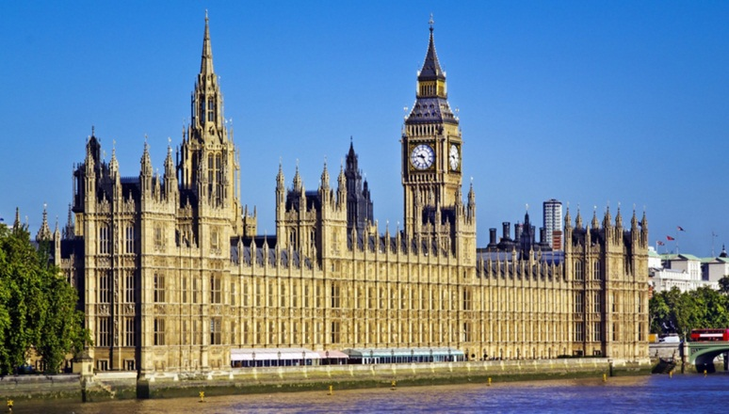
https://www.explorelondon.co.uk/parliament/?lang=he
The Houses of Parliament is the place of seating of the British government built in the 19th century. It is one of the most beautiful buildings in London. It combines history with modern art and architecture. The Houses of Parliament is divided into two parts, namely, the House of Lords and the House of Commons. In the building there are many rooms worth to see. They are, for example, Westminster Hall, Central Lobby, Lords Chamber, the Commons Chamber Queen’s Robing Room, and Royal Gallery.
- The Buckingham Palace
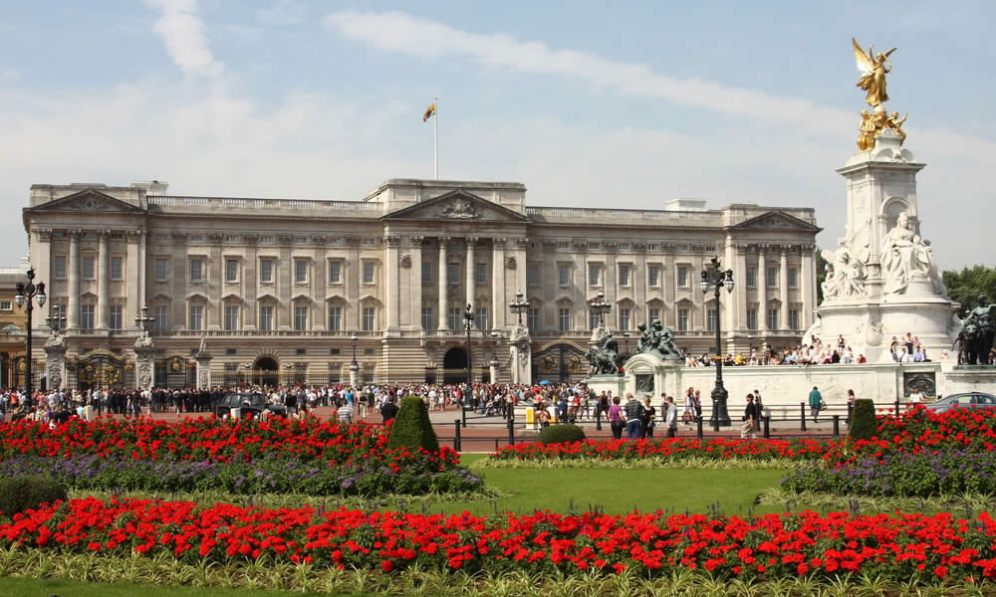
http://travelviaggiare.com/
The Buckingham Palace has been a Queen’s official residence in London since 1837. This is a place where the members of the Royal Family appear to wave on big holidays. It is situated very nearly the Houses of Parliament, so is visited by tourists very often as well. It was originally built for the Dukes of Buckingham but in 1761, when it was acquired by George III, it was renamed in “The Queen's Residence”. Its renovation lasted almost 75 years and the first queen that actually lived there was Queen Victoria. The Buckingham Palace consists of 775 rooms, there daily meetings and celebration ceremonials are held.
- The Westminster Abbey
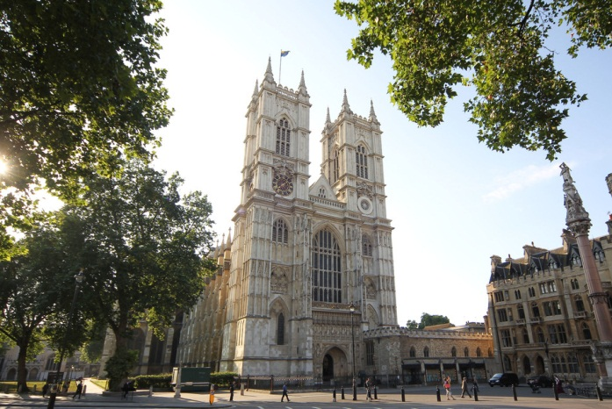
http://travelask.ru/blog/posts/4152-kakoy-gorod-samyy-krasivyy-v-mire
The Westminster Abbey is one of the most popular attractions to see in London. The Westminster Abbey is a medieval church constructed in Gothic style in the 11th century and dedicated by King Edward, its founder, to St Peter. It is the place of historic events of royal and national scale such as weddings, coronations, and burials.
The Westminster Abbey is a place of burying of many members of royal families and other prominent people, for example, Shakespeare, Chaucer, Newton, Cromwell, Churchill, Dickens and Darwin, Princess Diana, etc. Also, Westminster Abbey is well-known thanks to classical concerts performed here from time to time. It was included in the list of UNESCO world heritage sites.
- The Tower of London
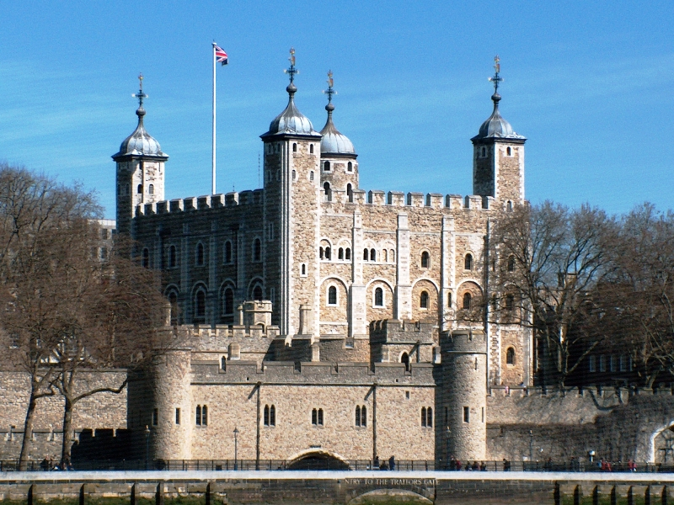
http://www.weekendsteden.nl/stedentrip/verenigd-koninkrijk/londen/
The Tower of London is one of the oldest buildings in London. It was built more than nine hundred years ago to guard the bridge that led into the city. Many kings lived there until the 17th century, when it became a prison.
In the Tower of London many famous people were imprisoned. Among others some famous people were incarcerated here. They are, for example, Anne Boleyn, the second wife of Henry VIII, executed in 1536, her daughter Elizabeth I released later, Sir Thomas More who was executed. This list can continue almost, it seems, to endlessness because the history of Great Britain was very rich in cruel murderings.
Nowadays beefeaters guard the Tower and guide the visitors. Their clothes are those of royal guards of the year 1500.
- The Big Ben
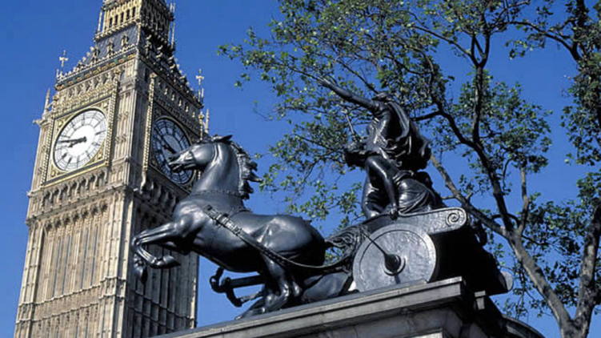
http://buildcsq.com/happy-birthday-big-ben-its-sound-is-common-sense-with-157-years-of-operation/
The Big Ben is a nickname for the largest clock of the Westminster Palace. It started to work on 31st May 1859. The Big Ben was constructed to strike every quarter of an hour. Its dials have seven meters in diameter and weigh about 100kg. Big Ben has rarely stopped. It survived even in the period of the Second World War. In 2012 The Big Ben was renamed in ‘the Elizabeth Tower’ in honor of Queen Elizabeth II.

